1. 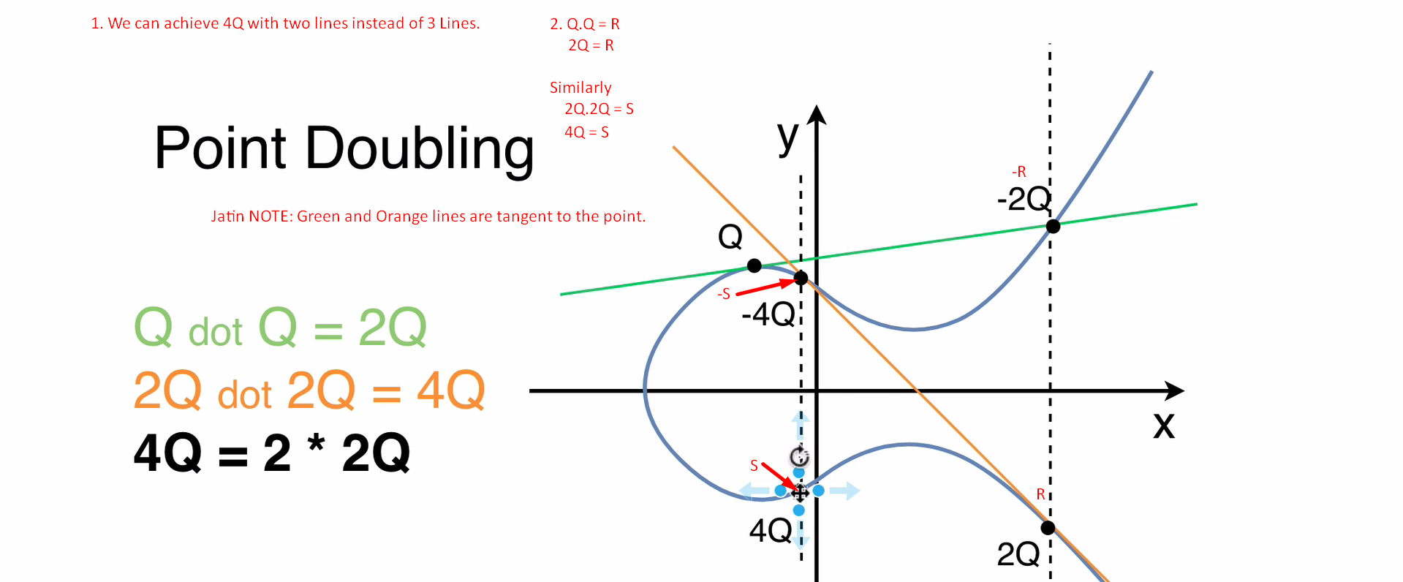
2. In the following snapshot, we are using Point Doubling and Point Addition (Scalar Addition) concept and operation.
3. 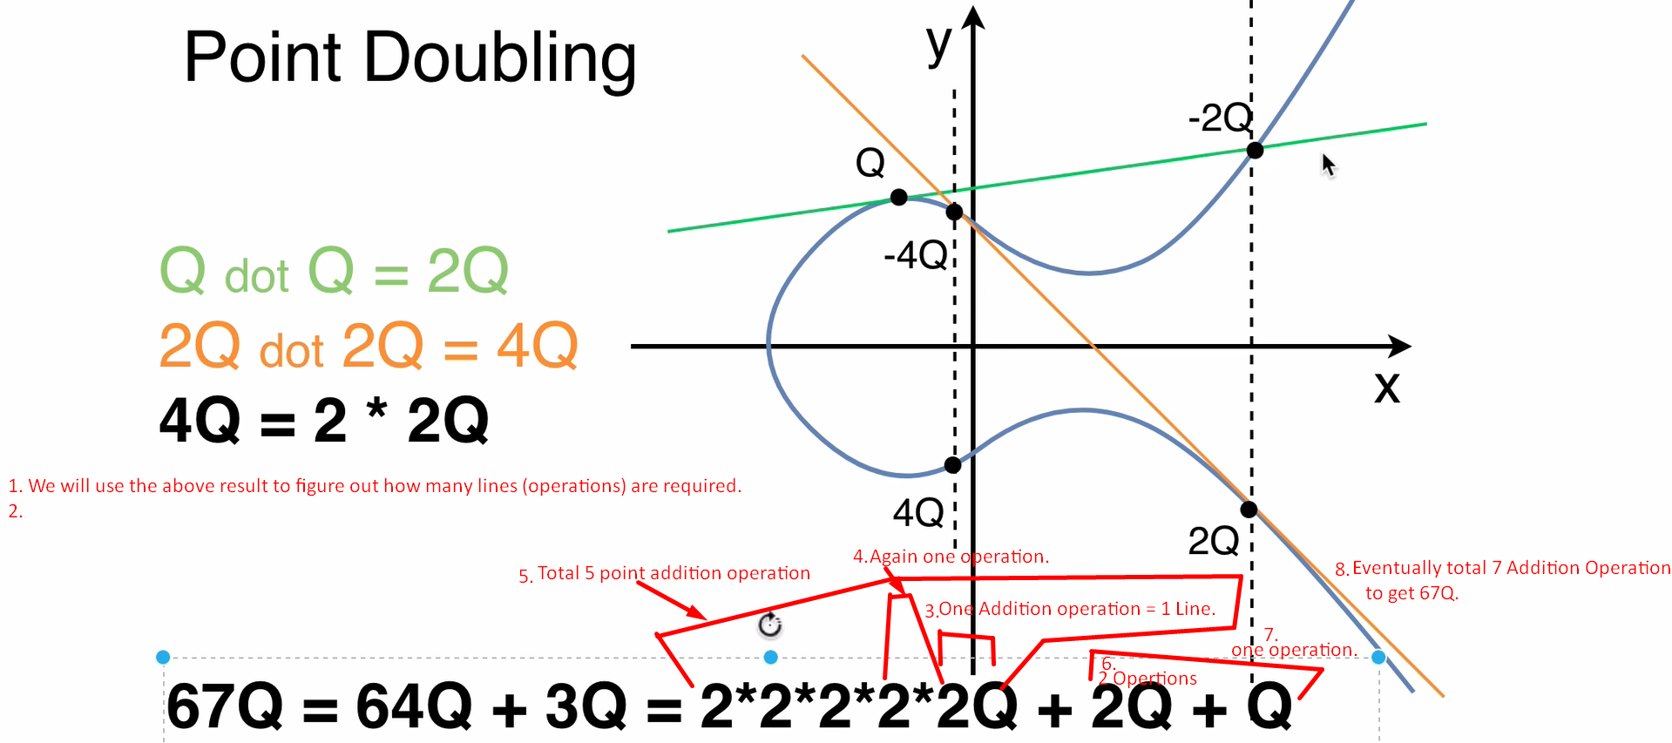  
   I think above it must be 2x2x2x2x2x2 = 2^6 = 64 but above there are five 2 but it must be six 2 multiplication.
4. 